**Name: Ritik Agarwal**

**Reg No: 19BCE1063**

**LAB 3**

**Internet Web Programming**

**OUTPUT SCREENSHOTS:**

**Q1: CSS BOX MODEL**

**WEBPAGE:** <https://m67l5av1grgd03z5yteb6g-on.drv.tw/www.ritik.com/csspage.html>

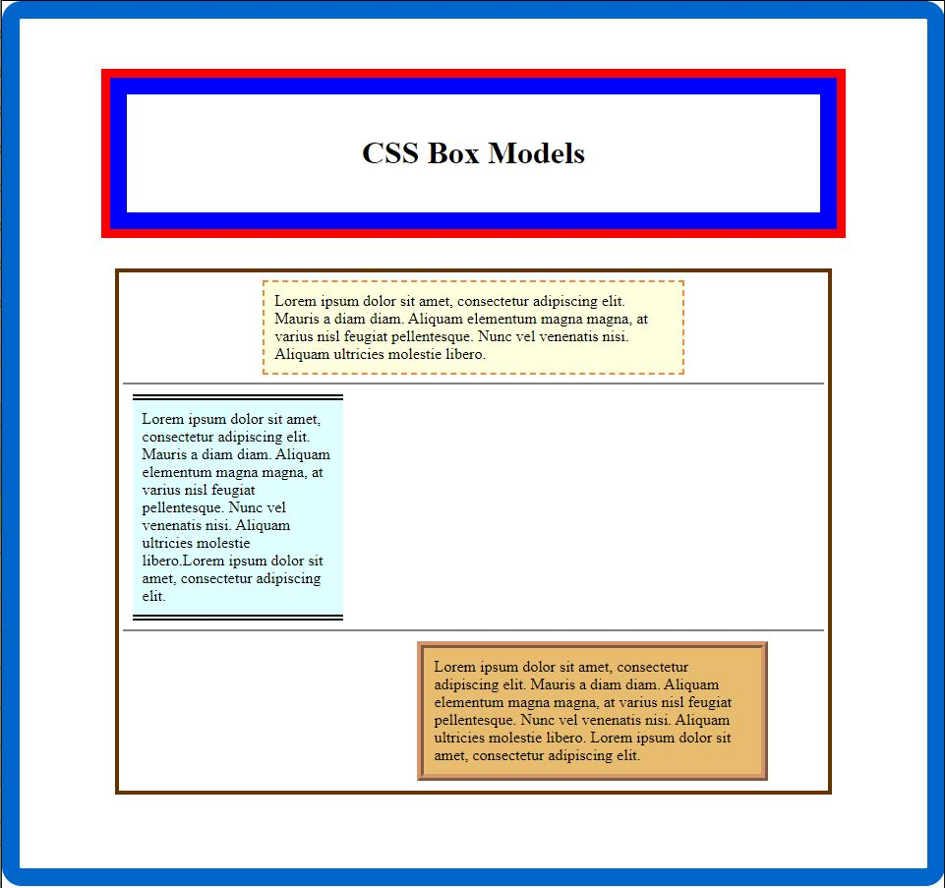

**Q2. Event Registration Form:**

**WEBPAGE**: <https://m67l5av1grgd03z5yteb6g-on.drv.tw/www.ritik.com/registerform.html>

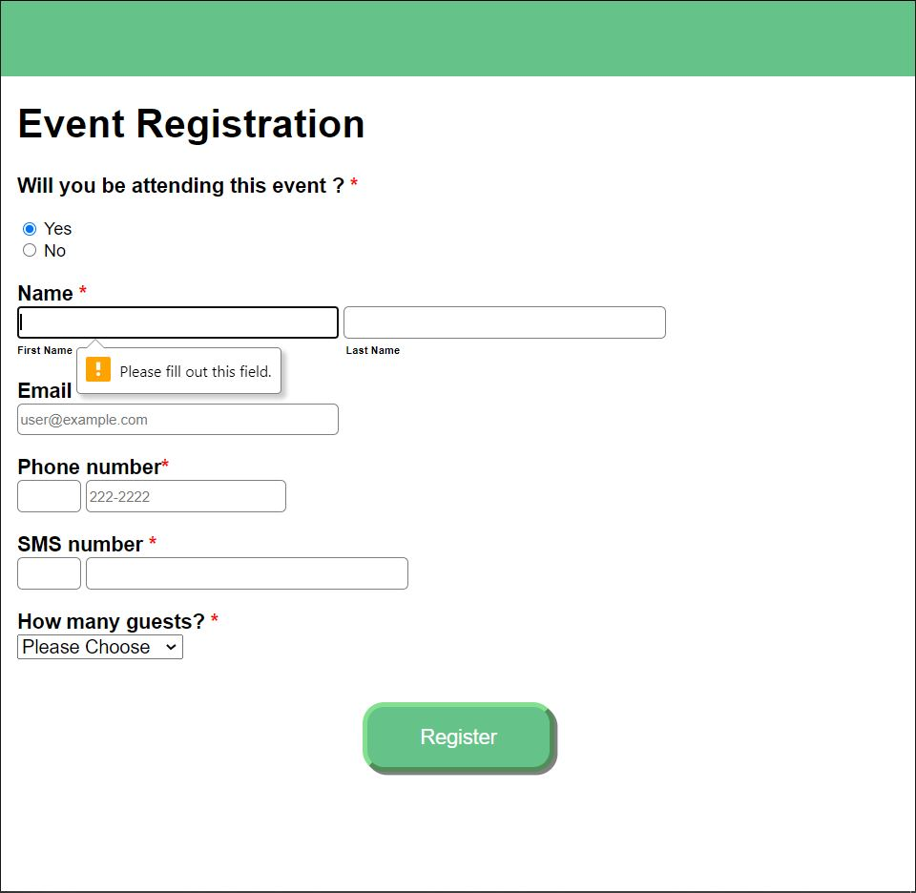

**Q3. Video Streaming Webpage:**

**WEBPAGE:** <https://m67l5av1grgd03z5yteb6g-on.drv.tw/www.ritik.com/videostreaming.html>

